Some Definitions of Mentoring:
Mentoring is a relationship between a more experienced employee and a less experienced one, built on mutual trust and respect, for the purpose of developing talent to its full potential.
Mentoring relationships ensure each employee receives a personalized development experience. The ultimate goal is an investment in each employee’s professional development and career.
Mentoring relationships provide mentees an opportunity to learn from experts to develop and grow into who they want to become.
Mentoring shows a commitment to all participants, and their success.
Mentoring is a social learning relationship occurring between a designated mentor (a more experienced member of a team) and at least one mentee (someone less experienced in a specific area), with the aim of giving guidance and sponsorship, and working together towards agreed objectives.

What is YOUR definition of mentoring?

What makes a good Mentor | What makes a good Mentee
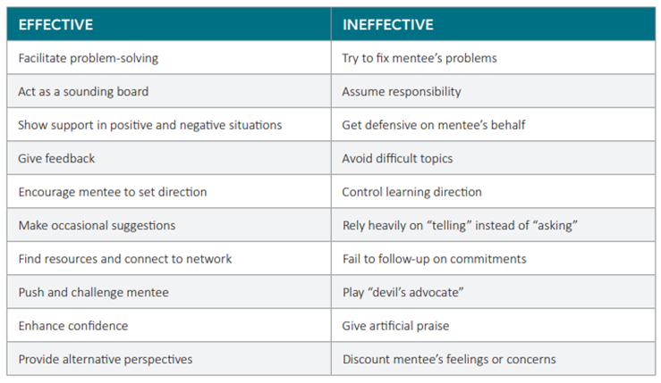

Role Play Scenarios:

1. You are working with a new mentee. She tells you that her goal for the mentoring relationship is to get promoted within one year. How would you work with her to refine her goal to be developmental and realistic in nature?
2. Your current mentee has hit what he calls a “rough patch.” He normally has a positive and cheerful outlook, but you have noticed that he has been very negative in the last couple of conversations. What questions could you ask to determine what is going on?
3. Several months into the mentoring relationship, your mentee has shown incredible progress on her development goals. She has worked hard between conversations to experiment and learn. How would you acknowledge and celebrate her progress?
4. After six months, your mentee has started to reschedule and even miss some of your meetings. When you do meet, he’s engaged, but he hasn’t done any work outside of the mentoring relationship. How would you approach your mentee to discuss the change in behavior?
5. You are getting ready to conclude the formal part of your mentoring relationship with your mentee. He’s done very well and made a lot of progress, but there’s still a lot of work for him to do. How would you help your mentee be prepared to continue on his learning journey after the mentoring relationship is over?

