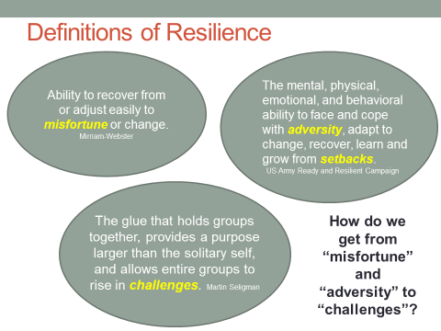

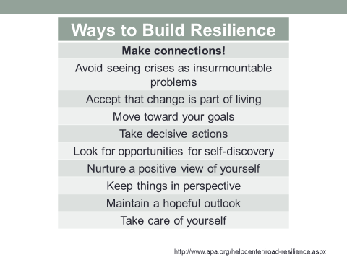

- To which of these methods do you connect? Give personal examples of how you do these things.
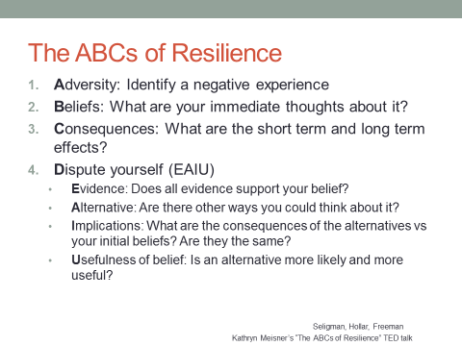

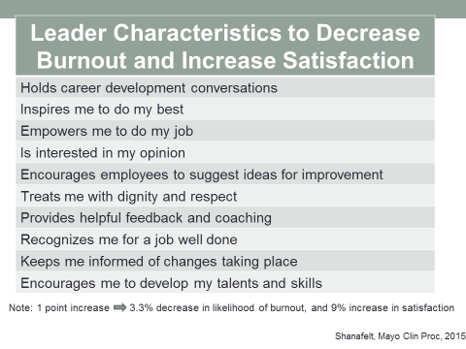

Think about a leader who has had an impact on your life (good or bad)

Discussion:
- How did your leader measure up?
- How would you measure up?
- Which of these factors are easy? Which are hard?
- Which factors can be taught? Which can be faked?
- Are they all achievable?

