- Write down 3 words that you associate with feedback.

- Were the above words generally positive or negative? Why is that? What can YOU do to change how you view feedback?

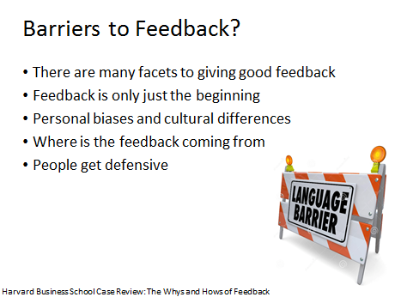

- Let’s compare Feedback vs Evaluations. Write 5 words that describe each.
Feedback | Evaluations

1.

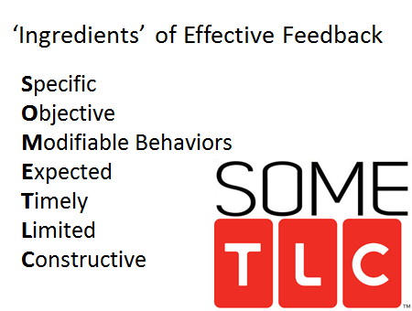
Specific- concise, instead of good job, be specific. Your hands shake instead of clumsy.
2. Objective-based upon observations and witnessed performance only and not hearsay.
3. Modifiable-focus on behaviors that are modifiable or/and will likely be repeated. You are addressing the behavior, not the individual
4. Expected-schedule. don’t blind side. Make it expected before an event
5. Timely-after every encounter or event. Timely also means appropriateness. If there is an emotional issue or fatigue is involved that requires things to cool off a bit. Good timing for feedback also ensures safety for the learner.
6. Limited. People tend to be able to deal with things in smaller amounts including feedback. Plus it is less time consuming. Give less but more frequent (such as at the end of each patient instead of at the end of a clinic)
7. Constructive-keep in mind that feedback is designed to help the learner improve and should be given for no other reason. Safety is also part of this key principle

Shit Sandwiches are still not palatable. Instead try:

Ask- How do you think you did/what do you think went well?
Tell/Teach- I observed…it seemed as though…in my experience…consider this.
Ask- What do you think of my comments…what would you do differently?
Act- Summarize key points, demonstrate, reassess, and commit to a plan

- Time to pair up! It’s roleplaying time. One of you is giving feedback to the other using what we just went over.

You are teaching a class via a series of interactive workshops. Most, but not all, students are there as an elective course. The curriculum requires reading between sessions. All sessions require active participation
One of your students, Pat/Patricia, started the course strong and you thought they were going to be one of the top students in the class. Recently, you note that he/she is frequently 4-5 min late for each session. He/She often seems to be poorly organized upon arrival. He/She is somewhat reluctant to be involved. Today during a group session He/she was texting on his/her phone. Another student asked her to participate or leave. He/She set the phone down, and returned to the activity.
When he/she does participate he/she gives insightful answers to the group. He/She is good at following specific directions when engaged. However this does not occur every session. You overhear a student stating, “Pat/Patricia is either completely unaware that he/she is a drag on our group, or he/she just doesn’t care.”

Give Pat/Patricia feedback on his/her performance using the Ask-Tell/Teach-Ask-Act method.

