I want you to think of the worst boss you have ever had. Write down one or two characteristics which made her/him so bad.

Now think about your best boss. Same thing. Write down one or two characteristics which made her/him so good.

The vast majority of attributes that elicit strong emotion from followers, good or bad, stems from emotional intelligence.

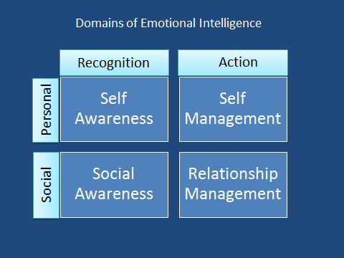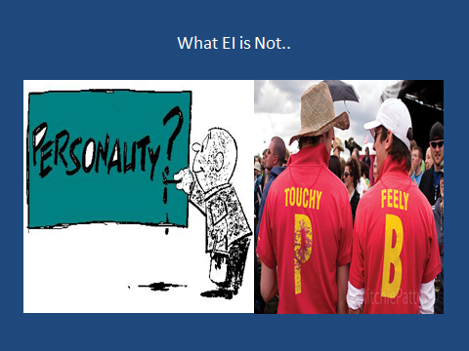

So who cares? Why does this matter? One of the best reasons is avoiding burnout. Between 40-50% of physicians are suffering from some level of burnout at any given time. Low emotional intelligence is a risk factor for burnout, whereas high EI is associated with increased patient and physician satisfaction. Additionally, low EI from a leader is associated with decreased morale and increased burnout of their people.

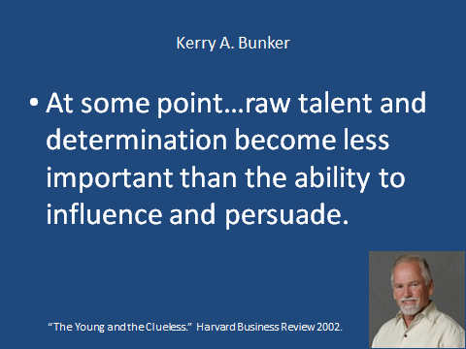

What Body Language indicates anger? Openness? Aloofness? Do you recognize when you do these things as often as you recognize them in others? How can we do better?

What do each of these body poses suggest to you?

